Project Design Phase-II

Data Flow Diagram & User Stories

|  |  |
| --- | --- |
| Date | 21 October 2022 |
| Team ID | PNT2022TMID23850 |
| Project Name | IoT Based Smart Crop Protection System For Agriculture |
| Maximum Marks | 4 Marks |

DATA FLOW DIAGRAM:

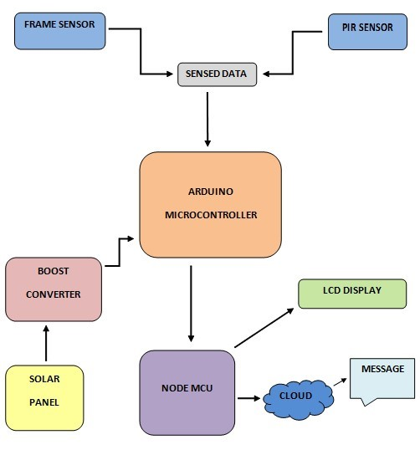

USER STORIES:

|  |  |  |  |  |  |  |
| --- | --- | --- | --- | --- | --- | --- |
| User Type | Functional  Requirement  (Epic) | User Story number | User Story/Task | Acceptance  criteria | Priority | Release |
| Customer  (Mobileuser) | Registration | USN-1 | User can enter into the web application | I can access my account / dashboard | High | Sprint 1 |
|  |  | USN-2 | User can register their  Credentials like e-mail id and password | I can receive Confirmation email & click confirm | High | Sprint 1 |
|  | Login | USN-3 | User can log into the application by entering email & password | I can log into my account | High | Sprint1 |
|  | Dashboard | USN-4 | User can view the temperature | I can view the data given by the device | High | Sprint 2 |
|  |  | USN-5 | User can view the  level of sensor monitoring value | I can view the data given by the device | High | Sprint 2 |
| Customer (Webuser) | Usage | USN-1 | User can view the web  Page and get the information | I can view the data given by the device | High | Sprint 3 |
| Customer | Working | USN-1 | User act according to  The alert given by the device | I can get the data work according to it | High | Sprint 3 |
|  |  | USN-2 | User turns ON the  Water motors/ Buzzer/ Sound Alarm when occur the disturbance on field | I can get the data work according to it | High | Sprint 4 |
| Customer  Care Executive | Action | USN-1 | User solve the  problem when some faces any usage issues | I can solve the issues when someone fails to understand the procedure | High | Sprint 4 |
| Administration | Administration | USN-1 | User store every information | I can store the gained Information | High | Sprint 4 |